The Two Lightning Bolt Strikes Thought Experiment

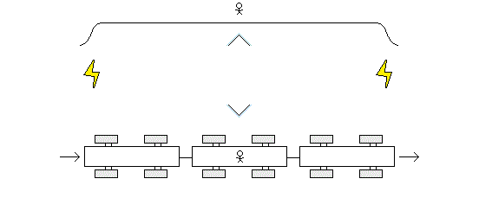

A man is sitting still on an embankment alongside a set of train tracks. He has two mirrors fashioned together in a v shape so he can see down the length of the train tracks in both directions at the same time.

There is also man on a train. The train is moving down the tracks. He too has a v shaped set of mirrors that allow him to see down the length of the train tracks in both directions at the same time.

When the man on the moving train reaches the point where the man on the embankment is sitting two lightning bolts strike two points along the train tracks at the same time. The two points where the lightning bolts strike are equal distances from the two men at the time of the strikes.

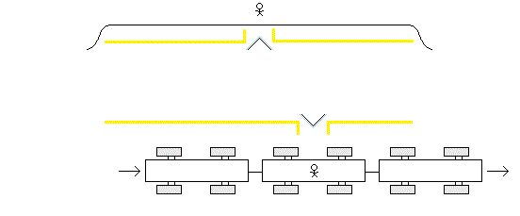

After the lightning bolts strike the train tracks the man on the train continues to move. As the flashes of light move towards the two men the man on the train moves towards one flash of light and away from the other.

With the distance between the man on the train and the one flash of light getting shorter and with the distance between the man on the train and the other flash of light getting longer, this means the man on the embankment will see the flashes of light simultaneously while the man on the train will see the flash of light he is moving towards before he sees the flash of light he moving away from.

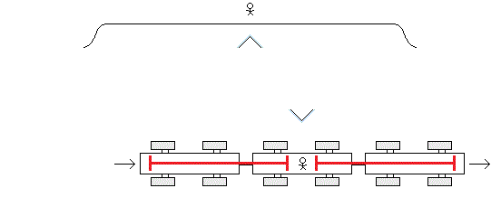

There is no known way to determine absolute rest. When two bodies are in motion relative to one another we cannot say which body is actually in motion and which body is actually at rest or if both are in motion and neither is at rest. And so it could be the train that is in motion or it could be the embankment that is in motion or both.

The Special Theory of Relativity tells us that the man on the train will consider himself to be at rest and the embankment to be in motion. And the Special Theory of Relativity tells us that the man on the train will consider the distances the two flashes of light have traveled to be the equal distances they have traveled relative to the train.

The Special Theory of Relativity also tells us that the man on the train will not see the one flash of light travel at a greater velocity towards him and the other flash of light travel at a lesser velocity towards him. He will see both flashes of light travel at the same velocity (300,000 km/sec).

So, if the two flashes of light have traveled equal distances at equal velocities but one arrives before the other, then, for the man on the train, the lightning bolt strike he is relatively moving towards must have occurred first and the lightning bolt strike he is relatively moving away from must have occurred later.

And so, Einstein concludes: “Events which are simultaneous with reference to the embankment are not simultaneous with respect to the train ....”

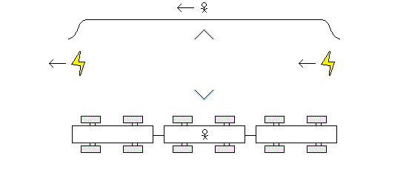

The Special Theory of Relativity tells us that the velocity of light is independent of the motion of the emanating source.

And so, for the man on the train, when the two lightning bolts strike the two points along the moving tracks and create the two flashes of light, the sources of these flashes of light (the points of impact) being in motion does not affect the velocity at which these flashes of light travel towards him.

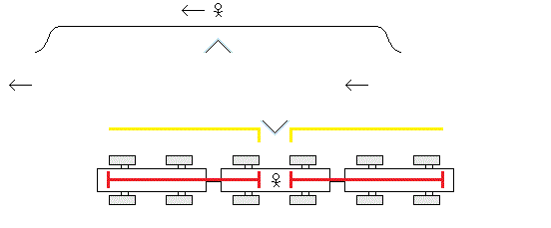

And so, in this thought experiment, given that the motion or lack of motion of the emanating source of the light is irrelevant, and given that it may be the man on the train who is at rest and embankment that is in motion, with the two flashes of light traveling at the same velocity over equal distances to the man on the train this means that the man on the train will see the two flashes of light at the same time.

To say that the man on the embankment will see the two flashes of light at the same time while the man on the train will see one flash of light before the other, is to say that the man on the embankment is the one actually at rest and the man on the train is the one actually in motion; which we cannot.

And to say that the man on the embankment will see the two flashes of light at the same time while the man on the train will see one flash of light before the other because “simultaneous events in one inertial frame of reference are not simultaneous in another inertial frame of reference” is a premise of this thought experiment and not just its conclusion is to engage in circular logic; which we should not.

The fact that the lightning bolt strikes occur outside the train and the man in the train is in the train is irrelevant. This thought experiment could just as easily have been proposed with a man sliding along the frictionless train tracks just by himself.

This thought experiment does not prove: “Events which are simultaneous with reference to the embankment are not simultaneous with respect to the train ....”

The theoretical justification for the Special Theory of Relativity is the validity of this thought experiment.

-----

Alternative Thought Experiment

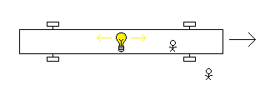

A different thought experiment was proposed by David Frost Comstock in 1910 (six years before Einstein proposed his two lightning bolt strikes thought experiment). Taking the premises of Einstein’s thought experiment and using them with Comstock’s thought experiment, it then does work.

In this thought experiment there is one light bulb in the middle of a moving car. It flashes. One flash of light goes to the front of the car. And another flash of light goes to the rear of the car.

From the perspective of the car at rest the man in the car will see the two flashes of light reach the front and the rear of the car simultaneously and from the perspective of the road at rest the man on the road will see the one flash of light reach the rear of the car first and then the other flash of light reach the front of the car later.

And so, given the premises, this proves: “Events which are simultaneous with reference to the embankment [car] are not simultaneous with respect to the train [road]....”

(FN: In his book Einstein takes some time to work out what he believes is the correct definition of “simultaneous” and he finds it in “If the observer perceives the two flashes of lightning at the same time, then they are simultaneous.” This alternative thought experiment does not prove that the flashes of light reaching the front and the back of the car are “simultaneous” for the man in the car in the way he defined this term. So, not only must the thought experiment be replaced with the alternative thought experiment but the definition of “simultaneous” must also be replaced. The definition he used does not apply here. In this thought experiment “simultaneous” cannot mean that identical clocks at the front and the rear of the car show the same time readings when the flashes of light reach them, because, if this theory is true, both the man in the car and the man on the road will say that the flashes of light reached the two clocks at identical time readings given the non-synchronization of clocks between inertial frames of reference. The man on the road has to measure the time the flashes of light reach the front and rear of the car based on synchronized clocks in his own inertial frame of reference. And so the man on the road would have to have two clocks: one at the point on the road corresponding to the rear of the car when the flash of light reaches it, and one at the point on the road corresponding to the front of the car when the other flash of light reaches it. The man in the car also has to have two clocks at the front and the rear of the car. And the definition of “simultaneous” is then identical time readings on these two clocks for each man in their own inertial frame of reference; which is the case for the man in the car and is not the case for the man on the road. And so in the revised statement “Events which are simultaneous with reference to the embankment [car] are not simultaneous with respect to the train [road]” the term “simultaneous” means something different than how Einstein defined it. It may be a trivial distinction but it should be noted.)

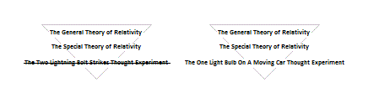

The General Theory of Relativity is resting on the Special Theory of Relativity and the Special Theory of Relativity is resting on the two lightning bolt strikes thought experiment and the two lightning bolt strikes thought experiment is false. The foundation of this theoretical structure must be revised.

(see Comstock, D.F. (1910), “The Principle of Relativity”, Science 31 (803): 767–772)

